**Pharmaceutical Expert System**

Submitted by

**Yaseen Al-Midani**

**Abstract**

This project provides services for patients that don’t know the right medicine for them. It provides medicines for patients that have symptoms such as cold, headache and sore throat, also chronic diseases such as Diabetes, Pressure and Asthma. The patient selects the given symptoms and chronic diseases (if the patient has) then the program returns the medicine that he/she should take.

Contents

Introduction 4

Chapter 1: Knowledge gathering 5

1.1 information gathering 5

Chapter 2: System Analysis 6

2.1 Decision tree 6

2.2 Pseudocode examples 8

2.3 Scenario steps 9

2.3.1 Scenario example 1 9

2.3.2 Scenario example 2 10

Chapter 3: implementation 13

3.1 Technologies used 13

3.2 Experta library 13

3.3 Output example 1 13

3.4 Output example 2 14

Difficulties 15

Future work 16

References 17

# Introduction

Have you ever got sick and you didn’t know what medicine to take? Well this application is what you need. This application helps the patient to decide which medicine he should take in certain situations. It also can save patient’s time going to the doctor to know what medicine you should take and sometimes it can save your life.

The idea of the project is to provide the medicine according to your selection of symptoms and the chronic diseases that you may have.

# Chapter 1: Knowledge gathering

## 1.1 information gathering

We asked the expert what is the right medicines to take for each situation that the patient may have and what is the differences between each medicine when the patients may have chronic diseases with the symptoms, then we separated each disease with its right medicine according to the knowledge that we have gathered from the expert.

# Chapter 2: System Analysis

## 2.1 Decision tree

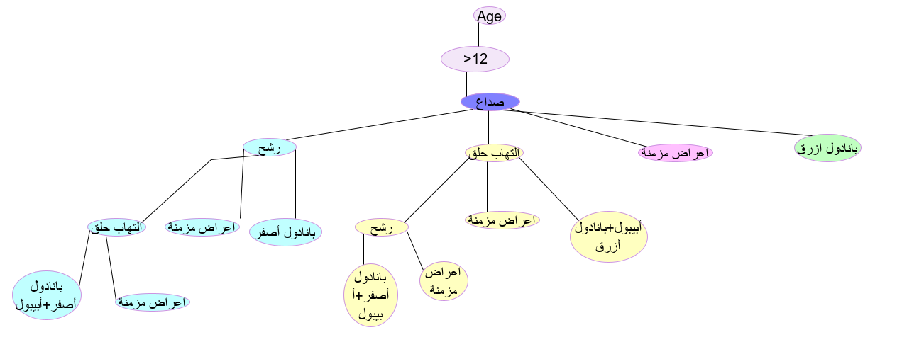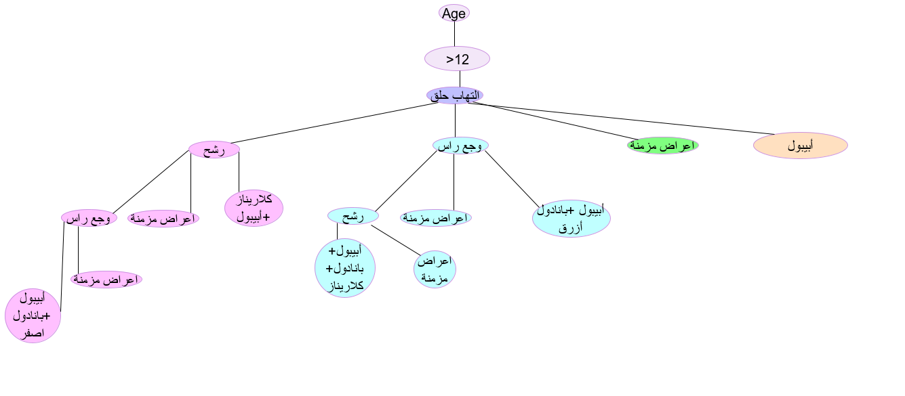

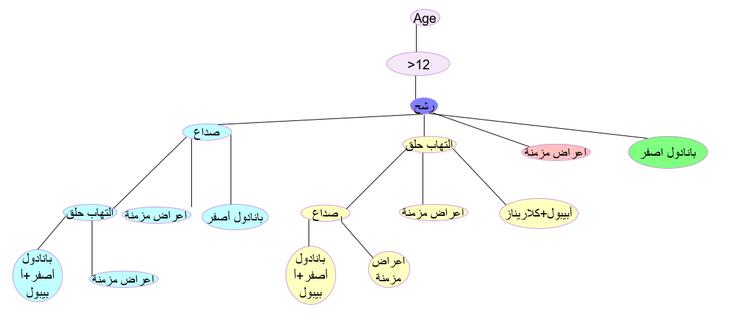

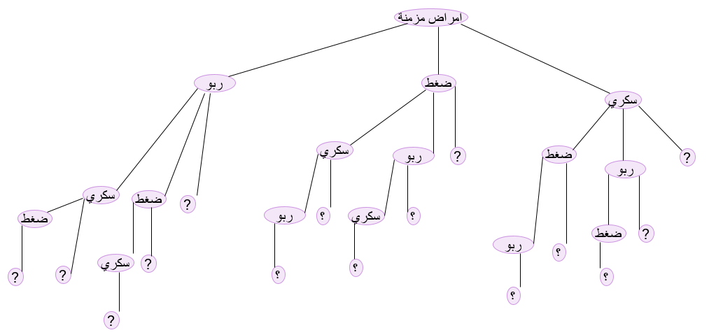

## 2.2 Pseudocode examples

R1: رشح

=>

Medicine is بانادول اصفر

R2: رشح, التهاب حلق

=>

Medicine is بانادول اصفر+ أبيبول

R3: رشح, صداع

=>

Medicine is بانادول أزرق+ كلاريناز

R4: صداع, التهاب حلق

=>

Medicine is بانادول أزرق+ أبيبول

R5: رشح, التهاب حلق, صداع

=>

Medicine is بانادول أزرق+ أبيبول+كلاريناز

## 2.3 Scenario steps

1. User enters age.
2. System asks the user to select one of the listed problems.
3. User selects a problem.
4. User can select another problem or continue.
5. System asks the user if he has a chronic diseases.
6. User selects on of the listed chronic diseases or continue.
7. System displays the medicine.

## 2.3.1 Scenario example 1

System displays: “enter your age”

User enters: 60.

System displays: “choose a pain

1. رشح
2. التهاب حلق
3. صداع

User enters: 1.

System displays: “Do you have another pain? (yes / no)”

User enters: no

System displays: “Do you have chronic diseases? (yes / no)”

User enters: yes.

System displays: “choose a chronic disease:

1. Asthma(ربو)
2. Pressure(ضغط)
3. Diabetes(سكري)

User enters: 3.

System displays: “Do you have another chronic disease? (yes / no)”

User enters: no.

System displays: “بانادول أزرق + فيتامين سي”

## 2.3.2 Scenario example 2

System displays: “enter your age”

User enters: 20.

System displays: “choose a pain

1. رشح

2. التهاب حلق

3. صداع

User enters: 3.

System displays: “Do you have another pain? (yes / no)”

User enters: yes.

System displays: “choose another pain

1. رشح

2. التهاب حلق

3. صداع

User enters: 1.

System displays: “Do you have another pain? (yes / no)”

User enters: no.

System displays : “Do you have chronic diseases? (yes / no)

User enters: yes.

System displays: “choose a chronic disease:

1. Asthma(ربو)
2. Pressure(ضغط)
3. Diabetes(سكري)

User enters: 1.

System displays: “Do you have another chronic disease? (yes / no)”

User enters: yes.

System displays: “choose another chronic disease:

1. Asthma(ربو)
2. Pressure(ضغط)
3. Diabetes(سكري)

User enters: 2.

System displays: “Do you have another chronic disease? (yes / no)”

User enters: no

System displays: “medicine is بنادول أزرق+قطرة أوتريفين”

# Chapter 3: implementation

## 3.1 Technologies used

The implementation of our project is built on python structure with experta library which is used by pycharm editor.

**  **

## 3.2 Experta library

Experta is a python library for building expert systems strongly inspired by CLIPS.

## 3.3 Output example 1

## 3.4 Output example 2

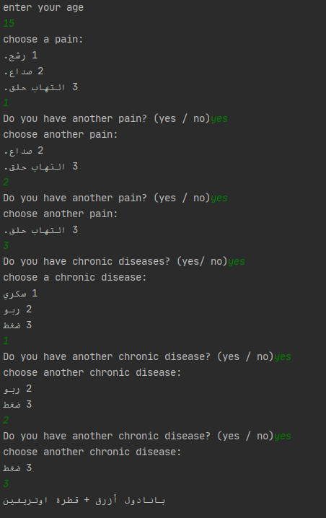

# Difficulties

In any project difficulties will appear in one of the phases of your project, in our project time was very limited.

In addition of time, learning the syntax of experta library was also impediment for us.

# Future work

In the distant future we can develop this expert system by:

* Adding more diseases and medicines which will help the patients to find all his needs.
* Build a system which can direct patient to doctors in case of patient could not find the appropriate medicine.
* Make the system related to a pharmacy and under the supervision of doctor.

# References

[1] experta library, [Online], site:

https://experta.readthedocs.io/en/latest